Cities - London
Vocabularies – Translate. (Přelož slovíčka.)

Bell -
Boat trip -
Firework -
Flag pole -
Fountain -
Kind -
Sightseeing-
Sore -
Tour -
Tourist office –
Tower –
Visit -
Square –
Theatre -

Read the article about Our trip to London on page 44. (Přečti si článek na straně 44.)
Answer the questions in English. (Odpověz na otázky v angličtině.)
Which historical sights can you find in London? Name them: _____________________________________
Where does the Queen live? ____________________________________________________
What is Big Ben? _________________________________________________
When were the Olympics in London? ____________________________________________________
How many minutes does it take to go round if you ride on the London Eye? _____________________________
What’s the name of the most famous bridge in London? ___________________________________________
Which river flows through London? __________________________________________________
Where can you find dinosaurs? _____________________________________________________

Name these tourist attractions. (Napiš název těchto turistických atrakcí.)

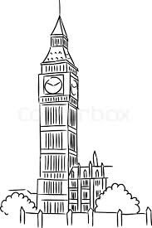
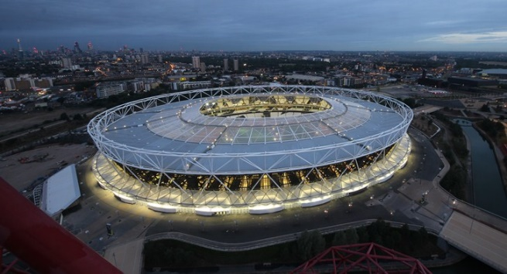
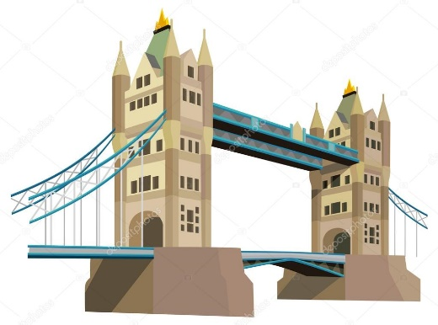

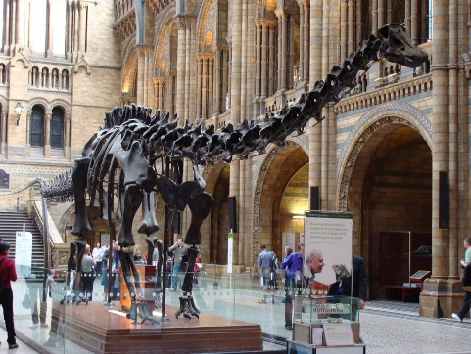
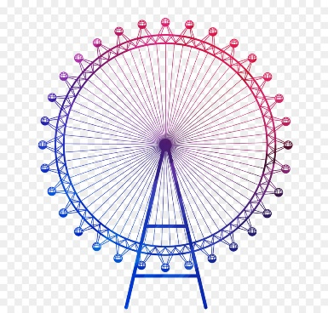
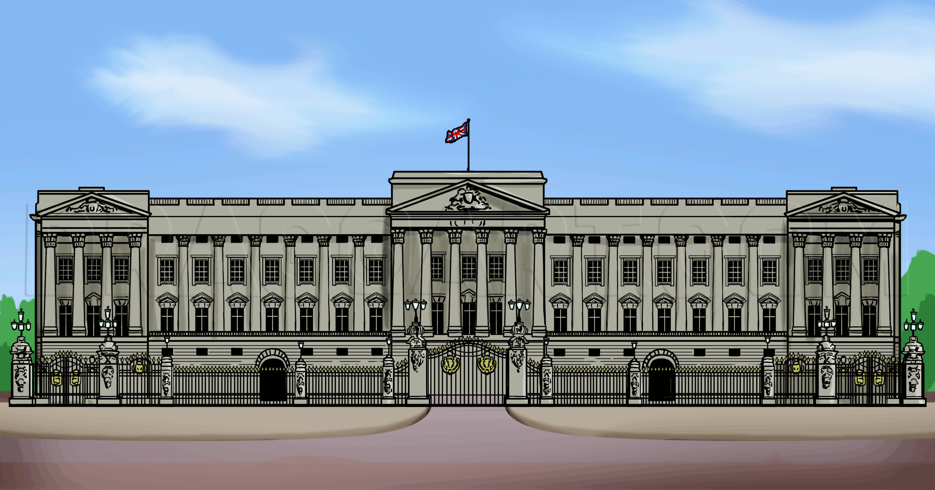

Quiz - London
- London is the capital of …. ?

- Scotland
- Ireland
- England

- The British flag is called …?

- The Red Cross
- The Union Jack
- The Stars and Stripes

- The British currency is …. ?

- The Euro
- The Pound
- The Dollar

- Typical British food is …. ?

- Fish and Chips
- Pizza
- Mashed potatoes

- The very famous music band coming from Liverpool is … ?

- Linkin Park
- Elvis Presley
- The Beatles

- The British like drinking … ?

- Tea
- Coffee
- Milk

- One of the most famous movie about young wizard is … ?

- Harry Potter
- Lord of the rings
- Sabrina

- The typical colour of British taxi is …. ?

- Yellow
- Red
- Black

- The famous writer in history was … ?

- J. K. Rowling
- J. R. R. Tolkien
- William Shakespeare

