Plague
- Vocabularies – Translate (Přelož slovíčka.)

Break out –
Bring –
Burn down –
Cause –
Death –
Destroy –
Discover –
Dry –
Flea –
Medieval –
Mud –
Narrow –
Outbreak –
Plague –
Compare -

- Read story about Plague on page 53 and answer the questions. (Přečti si článek na str. 53 a odpověz na otázky)
When did this terrible disease happen? _______________________________________________________
How did people call the plague? _____________________________________________________________
Where did plague come from? ______________________________________________________________
What caused the plague? __________________________________________________________________
What did people do to stop it? ______________________________________________________________
When was the last time that the plague came to London and why? ________________________________ _______________________________________________________________________________________
- Put the different events which happened in the story in the correct order. (Seřaď tyto události, kdy se staly čísly 1-9) – očíslování v učebnici není správné !
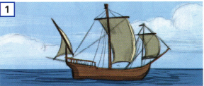
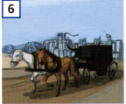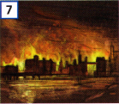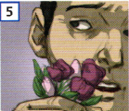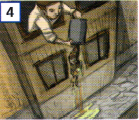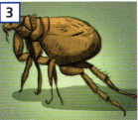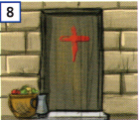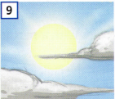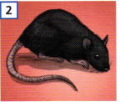

- Answer (Odpověz)
What similar to plague is happening today?
_____________________________________________________________________________________
- Crossword (Pokus se vyluštit křížovku na další straně pomocí překladače.) V křížovce jsou tato slovíčka, musíš si je přeložit do AJ a správně přiřadit k otázce. Přelož, co Ti vyjde v tajence.

Horečka –
Imunita –
Plíce –
Netopýr –
Asie –
Karanténa –
Světová zdravotnická organizace (zkratka) –
Umývat –
Teplo –
Koronavirus –
Létat –

1. What is the name of the virus which caused the current pandemic?
2. COVID was probably caused by animal. Which one?
3. You need to do something with your hands to reduce risk of coronavirus. What is it?
4. Coronavirus spread so fast from continent to continent because ill people do something in the plane. How we call it?
5. What is the national shortcut of World Health Organisation
6. One of the symptoms of coronavirus is high temperature. If it is higher than 37 °C. We call it ….
7. First continent where the coronavirus was registered is?
8. Most people with coronavirus have problem with breathing because COVID attack theirs…?
9. If you get COVID you must stay at home. We call it home….
10. COVID don’t like summer because sun is shining and weather is very…
11. To resist against COVID you have to eat a lot of vitamins and strengthen your….

1. |  |  | R
 |  |  |  |  |  |  |  | 2. |  |  | T
 |  |  |  |  |  |  |  |  | 3. |  |  |  | H
 |  |  |  |  |  |  |  | 4. |  | L
 |  |  |  |  |  |  |  |  | 5. |  | H
 |  |  |  |  |  |  | 6. |  |  |  |  | R
 |  |  |  |  |  |  |  |  |  | 7. | A
 |  |  |  |  |  |  |  |  |  | 8. |  | U
 |  |  |  | 9. |  | U |  |  |  |  |  |  |  | E
 |  |  |  |  |  |  |  |  |  | 10. |  | O
 |  |  | 11. |  |  | M

Tajenka: _____________________________________________

