Prepositions - předložky
Translate (Přelož)

Wardrobe - _________
Racket - _________
Shorts - _________
Shoes -_________
Roller-skates - _________
Sock - _____________
Belt - ____________
Magazine - ______________
Bag - __________
Table tennis - ____________
Skateboard - _____________
Towel - ___________

Minule jsme si zopakovali předložky in, on, under atd. Dnes si zopakujeme jejich používání v celé větě.

Look at the picture and answer the questions. (Podívej se na obrázek a odpověz na otázky.)
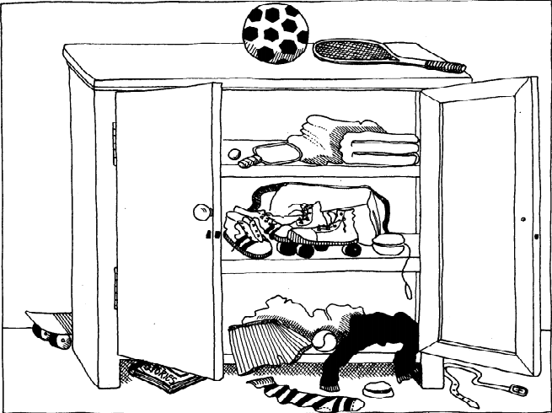

Příklad: Can you see a yo-yo in the picture? Where is it? The yo-yo is in the wardrobe next to a roller-skates.
Is there a skateboard in the picture? Where is it? _____________________________________________
Is there a football in the picture? Where is it? ________________________________________________
Can you see the roller-skates in the picture? Where are they? __________________________________
______________________________________________________________________________________
Can you see a belt? Where is it? ________________________________________________________
Can you see the magazine in the picture? Where is it? ______________________________________ ______________________________________________________________________________________
Can you see a bag? Where is it?____________________________________________________________
Everyday English – Introducing myself (Každodenní angličtina, představení se)
Pospojuj barevně: Otázku v pravém sloupci s odpovědí v levém sloupci
Hello, my name is Peter. What do you do in free time?
I’m 32 years old. What is your favourite colour?
I’m from Czech Republic. Where are you from?
I live in Ústí nad Labem. Where do you live?
My favourite colour is blue How many siblings do you have?
I have two brothers. How old are you?
My hobby is sport. What‘s your name?
I play tennis and volleyball. What is your hobby?

Answer the questions about yourself. (Odpověz na otázky o tobě)
What‘s your name?
My name is ___________.
How old are you?
I’m__________ years old.
Where are you from?
I’m from ________________.
Where do you live?
I live in ____________________.
What is your favourite colour?
My favourite colour is _____________.
What is your hobby?
My hobby is / hobbies are________________________________________________.
What do you do in free time?
I _________________________________________________.

