Time zones

**Vocabularies – Translate. (**Přelož slovíčka.**)**

Axis -

Excluding -

International Date Line -

Local -

Prime Meridian -

Set (sun) -

Time zone-

Standard -

Slowly -

Rotate -

**Read an article about time zones on page 41. (**Přečti si článek na straně 41.)

**Answer the questions in English. (**Odpověz na otázky v angličtině.**)**

How long does it take the Earth to turn around its axis? _________________________________________

When did the system of time zones start? ____________________________________________________

How did the people in 19th century tell the time? _________________________________________________

What changed when the railways arrived? ____________________________________________________

How many time zones are in the system of time zones? __________________________________________

Where is the start of the time zone system? (which place) _______________________________________________

How many time zones are in the USA? ____________________________________________________

How many time zones are in the Czech Republic? __________________________________________________

Is it possible to travel from today to yesterday? _____________________________________________________

**Určování času na mapě.** Anglie je ve středu a nic se nepřičítá ani neodečítá. Směrem na západ čas odečítáme, směrem na východ čas přičítáme.

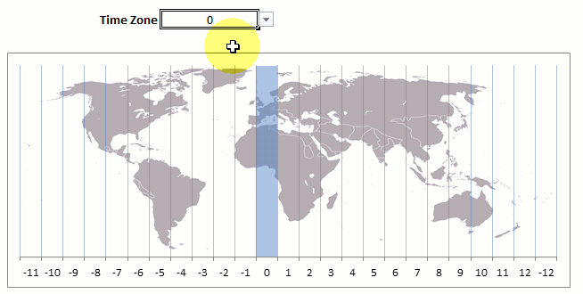

**Write the correct time in each place when it is 8 am in London. (**Napiš správný čas do posledního sloupečku v tabulce, pokud je v Londýně 8 hodin ráno).



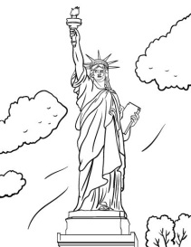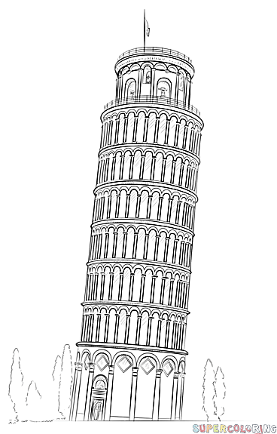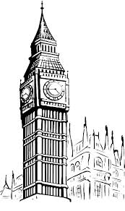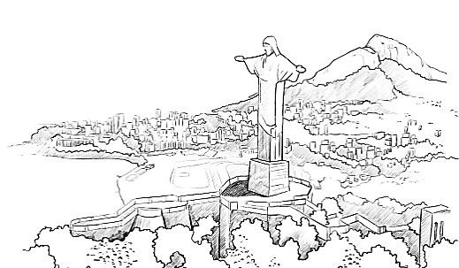**Fill the name of the country where we can find these monuments.** (Doplň název země, ve které najdeme tyto památky)**.**

