Výpočet přepony
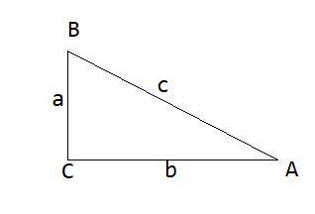
Doplň do obrázku pravý úhel, napiš vzorec pro Pythagorovu větu, vypočti přeponu c:
Vzor řešení:
a = 8 cm
b = 6 cm
c = x cm
Postup:
c² = a² + b²
c² ⁼ 8² + 6²
c² = 64 + 36
c² = 100
c = $\sqrt{100}$
c = 10 cm

- Vypočti příklady: a = 7 cm
b = 5 cm
c = x cm
Postup:
c² = a² + b²
c² ⁼ ² + ²
c² = +
c² =
c =
c = cm

- a = 5 cm
b = 8 cm
c = x cm
Postup:
c² = a² + b²
c² ⁼ ² + ²
c² = +
c² =
c =
c = cm

- a = 28 cm
b = 42 cm
c = x cm
Postup:
c² = a² + b²
c² ⁼ ² + ²
c² = +
c² =
c =
c = cm

Výpočet odvěsny
Vypočti odvěsnu v pravoúhlém trojúhelníku se stranami:
c = 10cm, b = 6 cm

Vzor řešení:
a = x cm
b = 6 cm
c = 10 cm
Postup:
a² = c² - b²
a² ⁼ 10² - 6²
a² = 100 - 36
a² = 64
a = $\sqrt{64}$
a = 8 cm

Postupuj podle vzoru

1)
a = x cm
b = 12 cm
c = 15 cm
Postup:
a² = c² - b²
a² ⁼ ² - ²
a² = -
a² =
a =
a = cm

2)
a = 16 cm
b = x cm
c = 20 cm
Postup:
b² = c² - a²
a² ⁼ ² - ²
a² = -
a² =
a =
a = cm

